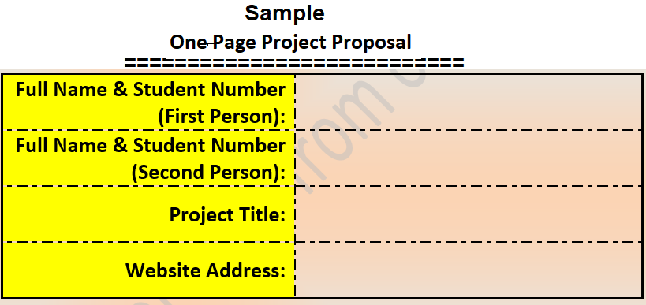

**India’s Transportation System**

**https://github.com/Manjot811534/Project-Transportation-**

**Manjot Kaur 811534**

**Manjot Kaur 812955**

Description:

We are going to make a webpage and presentation with some interactive activities on transportation system in India. This project aims to analyze how India has different kind of transport facilities . In India, how different kinds of transport facilities are providedby different provinces. Our project is going to include means of transport like metros, cars, buses, and many other things. We are also going to give an overview of how modes of transportation vary in different provinces, like how some provinces have a metro facility which connects all the areas whereas some provinces just have buses which are used as means of transportation. As India is a very large and diverse country so are project is going to show diversity in modes of transportation in India.

We are going to perform these tasks:

1. We are going to investigate different kind of modes of transportation used in India and how they vary according to the need of people.
2. We are going to differentiate between different modes of transportation, and how new emerging modes of transportation are introduced by the government.

A webpage will be made using html and CSS and we will be working together on it whereas presentation, sources and necessary information will be gathered by Manjot Kaur (811534) and coding will be performed by Manjot Kaur(812955).

We going to make our project using the functions given below:

1. Multiple iframes
2. Conditional Statements
3. Loops
4. Functions
5. Arrays
6. URL links
7. Images
8. Objects
9. Multimedia features

We are going to use all the things we have learned in class until now like HTML tags like div, section, a, p, text area and many more.

In this project CSS tags will also be used along will java script and various interesting kinds animations and graphics will be added in our project.